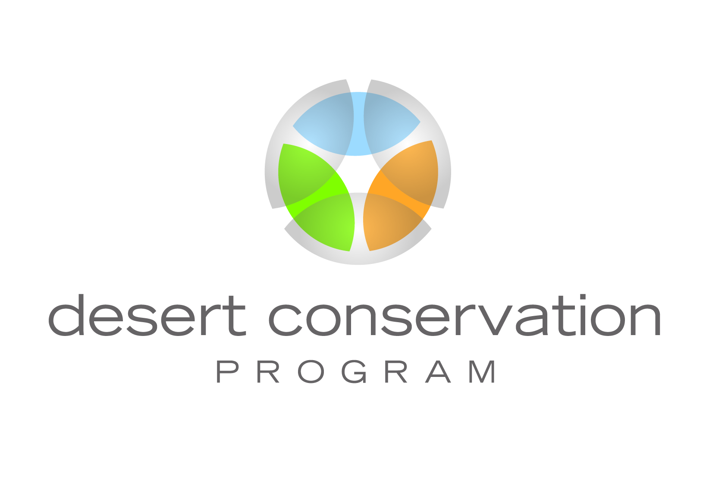

INVOICE CHECKLIST

Your contract/Interlocal agreement and Scope of Work contain detailed information on invoicing requirements. Please review the pertinent sections in those documents for invoicing requirements specific to your project.

Please ensure the following information is included on your invoice:

- Agency/company name and address
- Date
- Invoice Number
- Project Number (i.e. #2003-USFS-234-P – issued by the DCP)
- Project Title (as listed in your Contract/Interlocal Agreement or Scope of Work)
- Purchase Order Number (issued by Clark County Purchasing)
- Description of items for payment and amount
- Total amount requested for payment
- Name and contact information of representative that can answer questions regarding the invoice
- Any change to your “remit payment to” address has been communicated in writing to DCP prior to invoicing

Please ensure the following information is submitted with your invoice:
- Budget summary comparison
- If time and materials contract/Interlocal agreement, backup documentation (original receipts for supplies/equipment, travel receipts, etc.) and personnel cost breakdown (position, rate, dates worked, time worked)
*Please submit original receipts, if receipts are smaller than 8.5 X 11 please tape them to an 8.5 X 11 sheet of paper

Note: Deliverables for which you are invoicing should not be attached as backup documentation to your invoice, but must be submitted to Clark County prior to invoicing and approved prior to payment. No exceptions will be made.

- Deliverables for which payment is being requested have been submitted and approved

